Query-> Sol-1

select salesman.name , customer.cust_name, customer.city from salesman, customer

where customer.city = salesman.city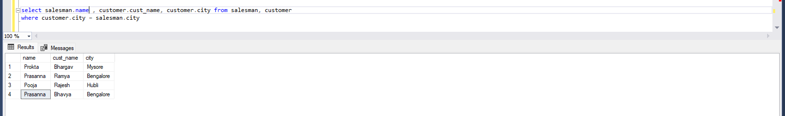

Query-> Sol-2

select orders.ord_no, orders.purch_amt, customer.cust_name, customer.city from customer,orders

where purch_amt between 500 and 2000 and customer.customer_id = orders.customer_id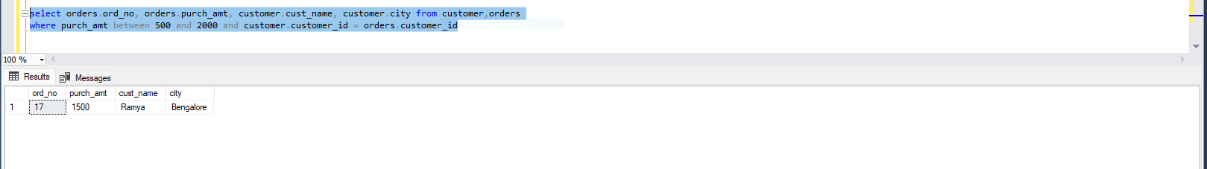

Query-> Sol-3

select customer.cust_name, customer.city,salesman.name, salesman.commission from salesman,customer

where salesman.salesman_id = customer.salesman_id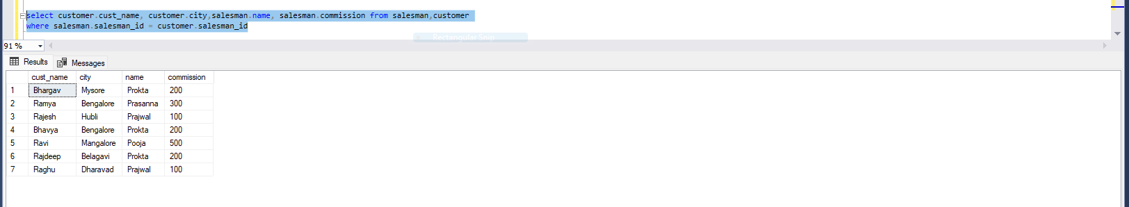

Query-> Sol-4

select customer.cust_name ,customer.city, salesman.name, salesman.commission from salesman, customer

where salesman.commission > 12 and salesman.salesman_id = customer.salesman_id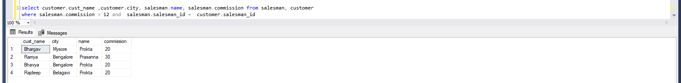

Query-> Sol-5

select customer.cust_name, customer.city, salesman.name , salesman.city from customer, salesman

where customer.city != salesman.city and salesman.commission > 12 and customer.salesman_id = salesman.salesman_id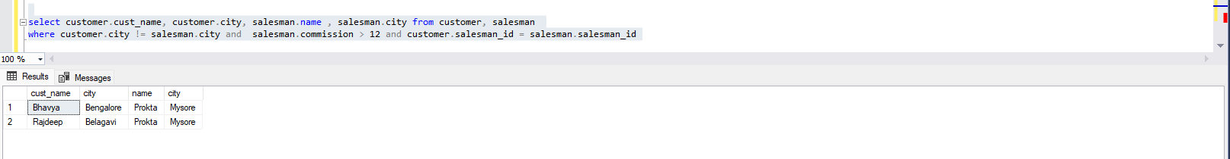

Query-> Sol-6

select orders.ord_no, orders.ord_date, orders.purch_amt, customer.cust_name,customer.grade, salesman.name,salesman.commission

from ((orders

left join customer on orders.customer_id = customer.customer_id)

left join salesman on orders.salesman_id = salesman.salesman_id

)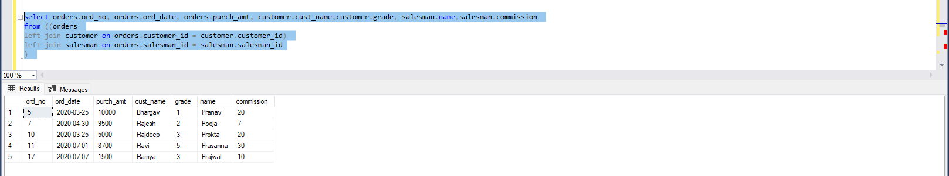

Query-> Sol-7

Select * from orders O

inner join customer C on O.customer_id = C.customer_id

inner join Salesman S on O.salesman_id = S.salesman_id

where S.salesman_id = O.salesman_id and O.salesman_id = C.salesman_id

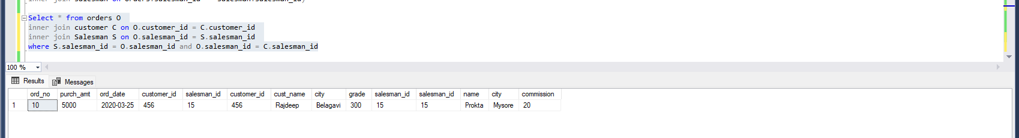

Query-> Sol-8

select customer.cust_name, customer.city, customer.customer_id, salesman.name, salesman.city

from customer

left join salesman

on customer.salesman_id = salesman.salesman_id

order by customer.customer_id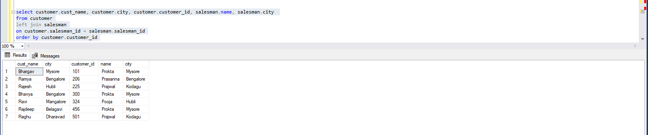

Query-> Sol-9

select customer.cust_name, customer.city, customer.grade,salesman.name as salesnamName,salesman.city as SalesmanCity

from customer

left join salesman on customer.salesman_id = salesman.salesman_id

where customer.grade < 300

order by customer.customer_id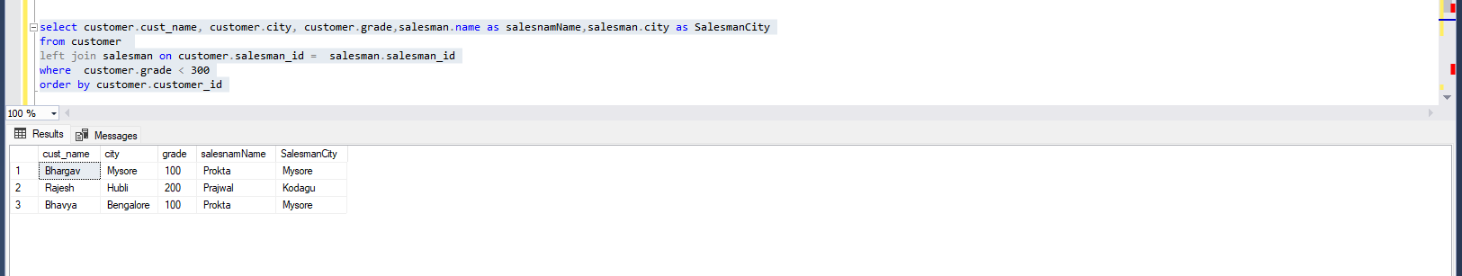

Query-> Sol-10

select customer.cust_name, customer.city, orders.ord_no,orders.ord_date,orders.purch_amt

from customer

left join orders on customer.customer_id = orders.customer_id

order by orders.ord_date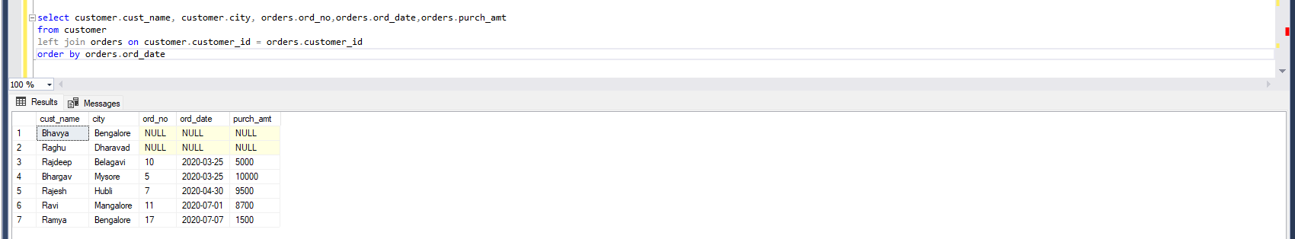

Query-> Sol-11

select customer.cust_name, customer.city, orders.ord_no, orders.ord_no, orders.ord_date,orders.purch_amt,salesman.name, salesman.commission

from ((customer

left join orders on orders.customer_id = customer.customer_id

)

left join salesman on orders.salesman_id = salesman.salesman_id) 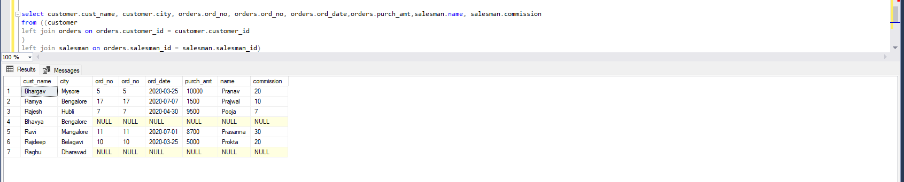

Query-> Sol-12

select c.salesman_id,c.cust_name,c.grade,c.cust_name ,c.city

from customer c

right join salesman s on s.salesman_id = c.salesman_id

order by s.salesman_id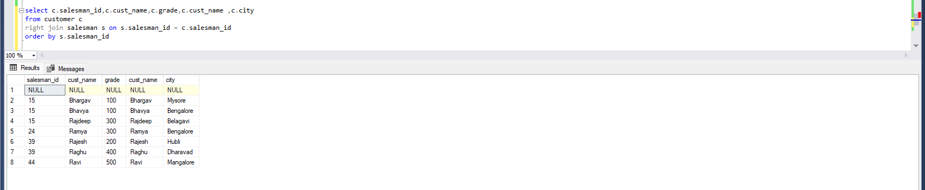

Query-> Sol-13

select s.name as NameOfSelesman ,c.cust_name,c.city,o.ord_no,o.ord_date,o.purch_amt

from ((salesman s

left join orders o on s.salesman_id = o.salesman_id )

left join customer c on c.salesman_id = s.salesman_id)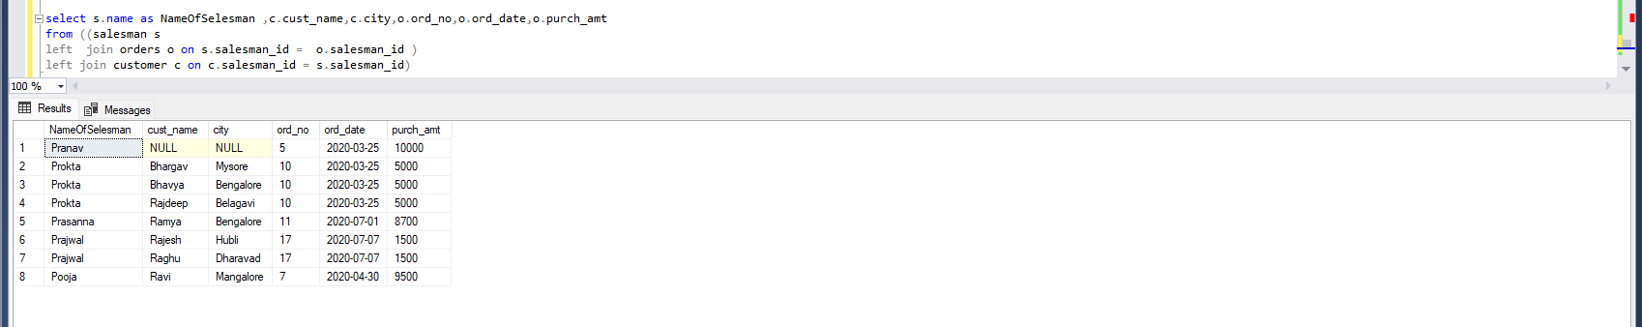

Query-> Sol-14

select s.name as salesman , c.grade, o.purch_amt,c.cust_name as CustomerName

from ((customer c

right join salesman s on s.salesman_id = c.salesman_id)

left join orders o on o.customer_id = c.customer_id)

where o.purch_amt >2000 and c.grade is not null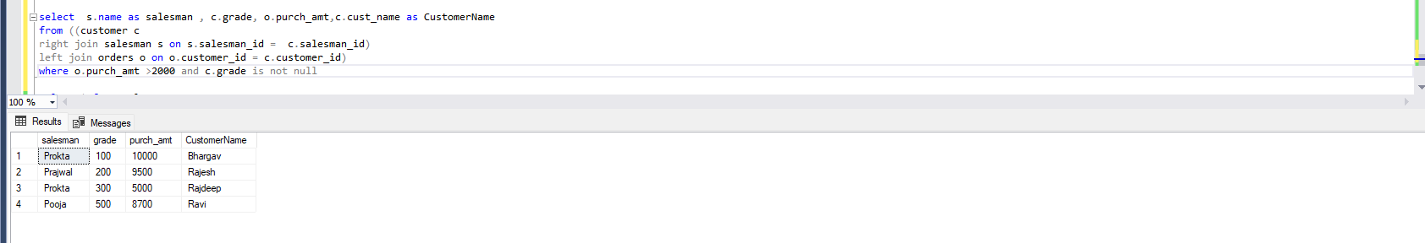

Query-> Sol-15

select s.name as salesman , c.grade, o.purch_amt,c.cust_name as CustomerName

from ((customer c

right join salesman s on s.salesman_id = c.salesman_id)

left join orders o on o.customer_id = c.customer_id)

where o.purch_amt >2000 and c.grade is not null

Query-> Sol-16

select c.cust_name as CustomerName,c.city,o.ord_no,o.customer_id,o.purch_amt

from customer c

left join orders o on c.customer_id = o.customer_id

where c.grade is not null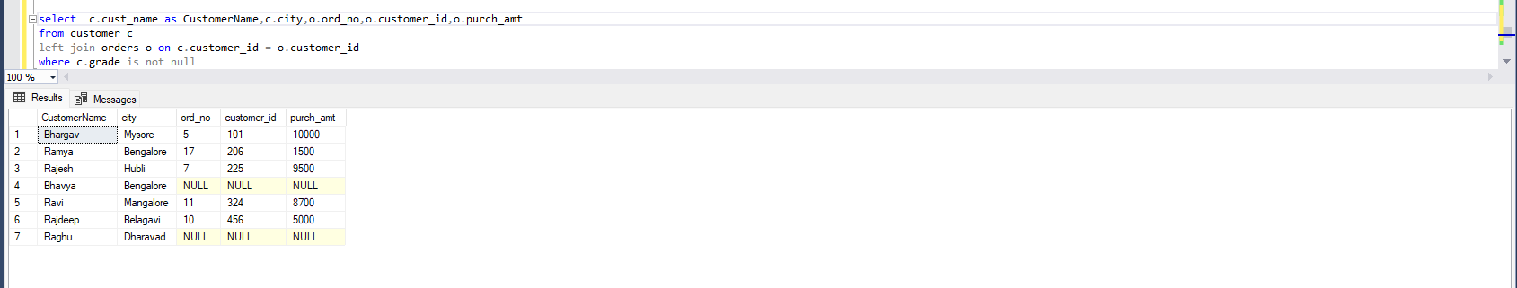

Query-> Sol-17

select * from salesman

cross join customer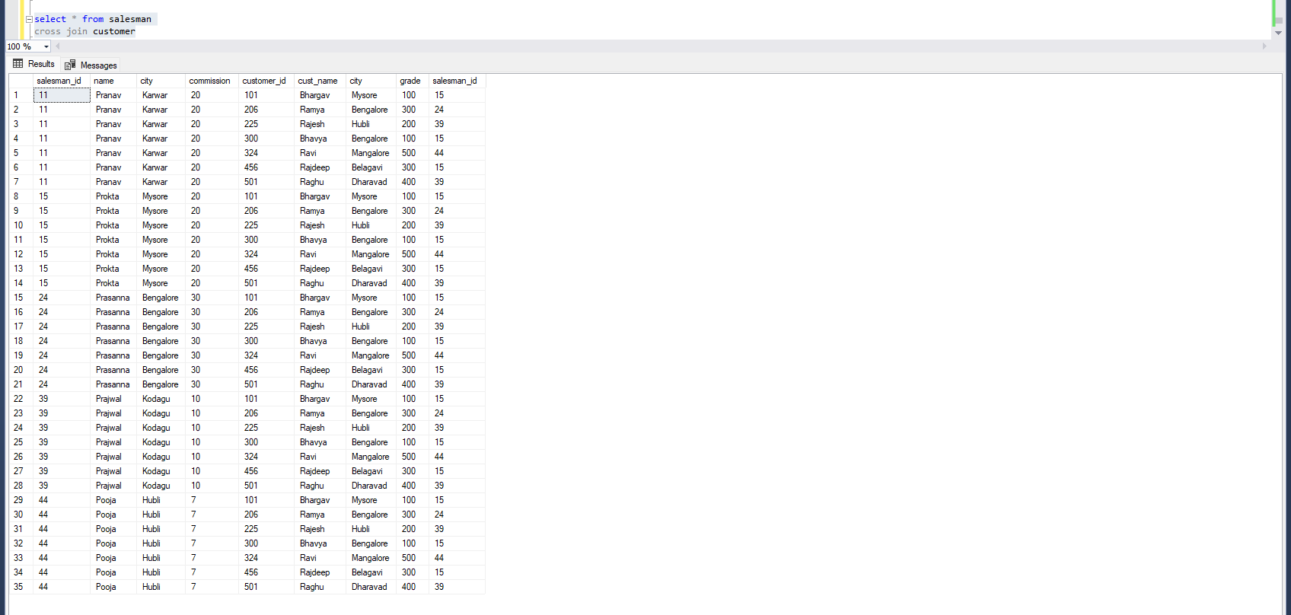

Query-> Sol-18

select * from salesman

cross join customer

where salesman.city is not null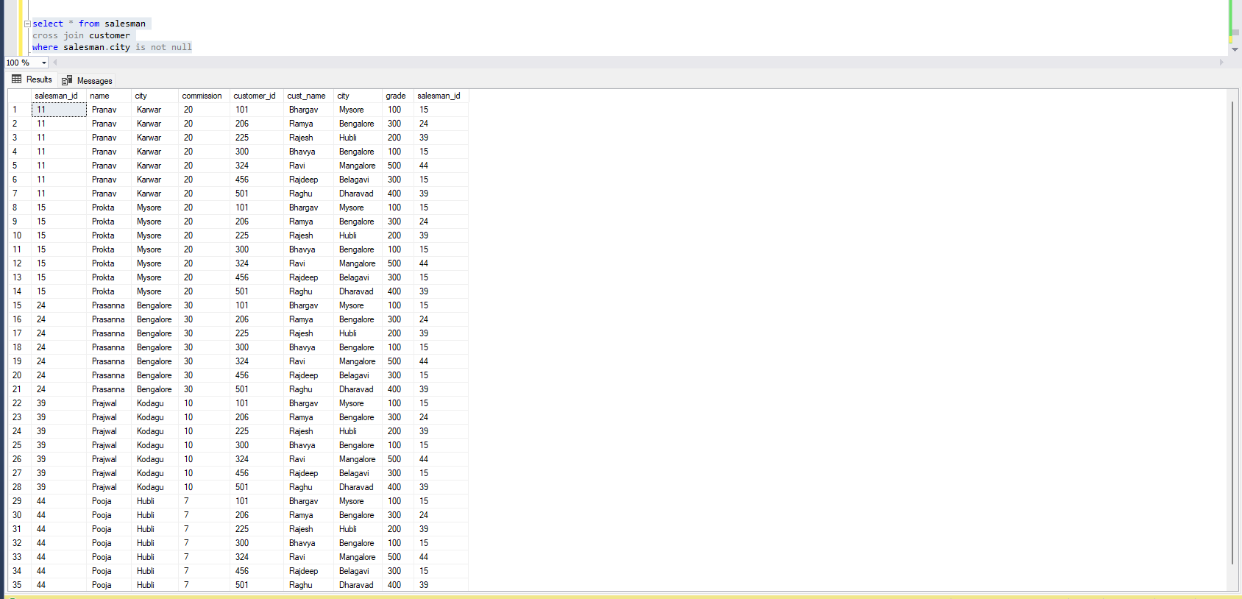

Query-> Sol-19

select s.name as salesPerson , c.cust_name as customerName , c.grade

from salesman s

cross join customer c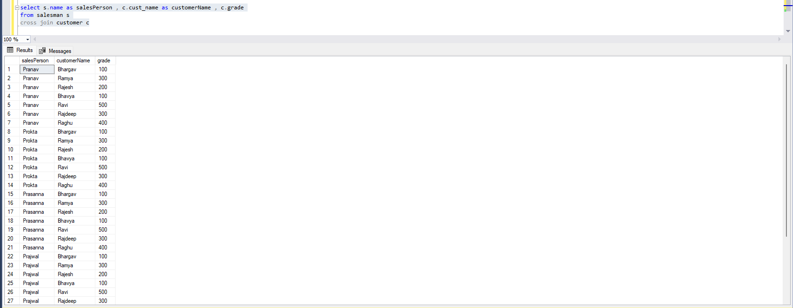

Query-> Sol-20

select * from salesman s

cross join customer c

where s.city<>c.city and s.city is not null and c.grade is not null

